Spike: Spike 12
Title: Game State Management

Author: Rachel McQueenie 696737x

Goals / deliverables:
- A simple paper-based plan for your code design.
- Create a simple console program that implements the “Zorkish: Phase I” game (although it has no gameplay yet) using a flexible (extensible) game state management method of some kind. Must demonstrate the following game stages (states):
  - “Main Menu” (which allows the user to select other stages…)
  - “About” (remember to include your own details here)
  - “Help” (summary of commands – simple hard-coded text is fine)
  - “Select Adventure” (use a hard-coded list and the title of your test game)
  - “Gameplay” (test game which only accepts “quit” and “hiscore” commands)
  - “New High Score” (allows user to enter their name, but doesn’t work yet)
  - “View Hall Of Fame” (view list of name/score. Simple hard-coded text is fine.)

Technologies, Tools, and Resources used:
- Windows 7 / 8
- Visual Studio Professional 2012 / Ultimate 2012

Tasks undertaken:
- Design the system on paper (refer to Appendix A-D)
- Create the State class, which is an abstract / interface class. Our states will inherit from this later
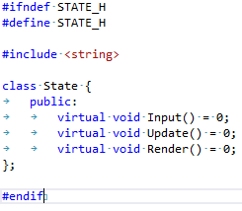
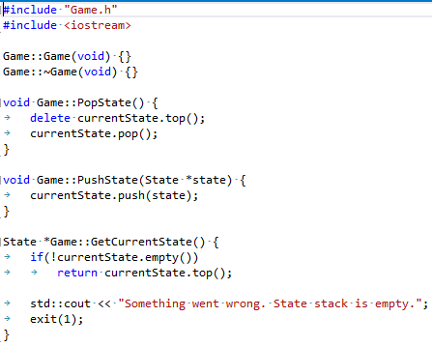
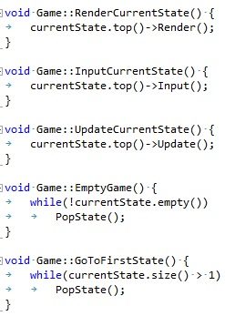
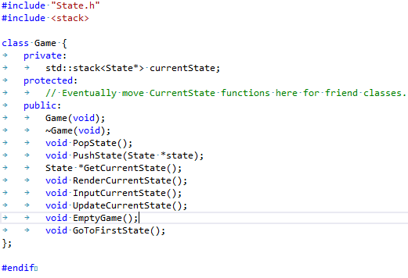
- Create the Game class. This will contain a stack of states and will control most of the state management.
- Create the states to be used for the Main Menu:
  - About State
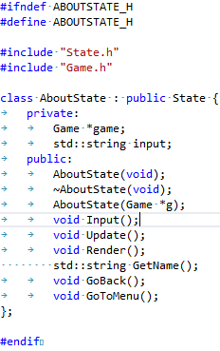
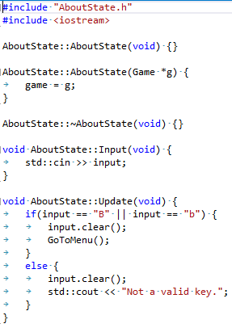
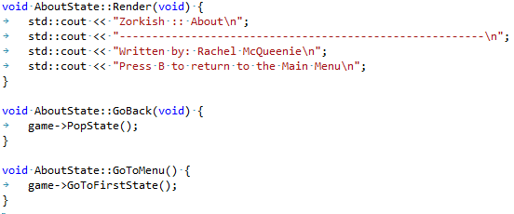

  - Hall of Fame State
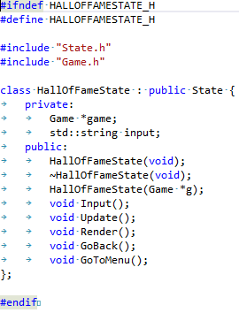
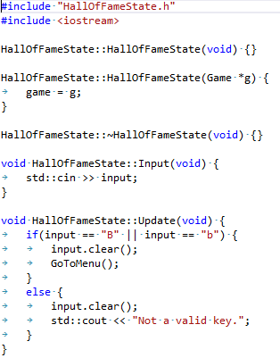
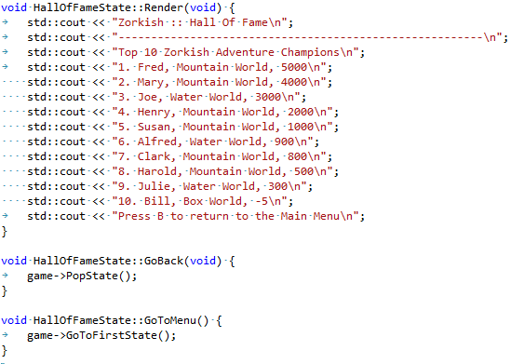

  - Help State
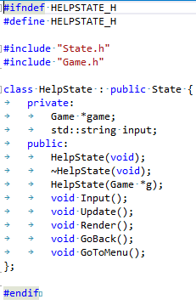
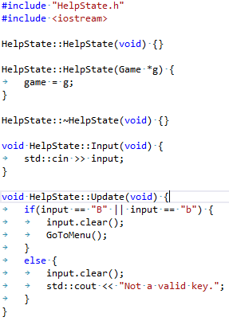
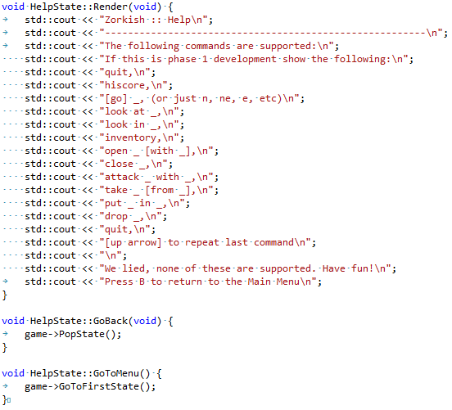

  - And of course, Main Menu State
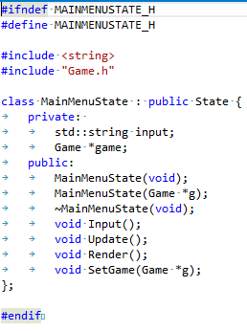
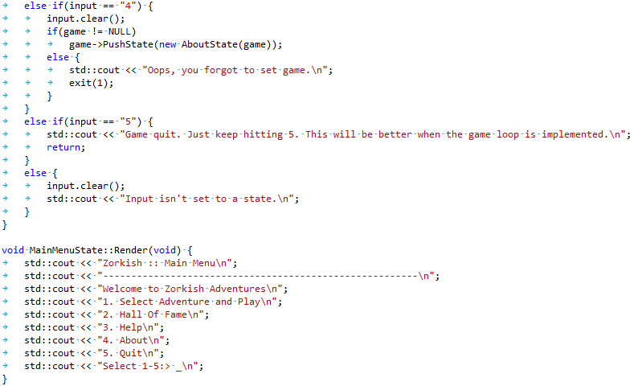
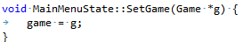
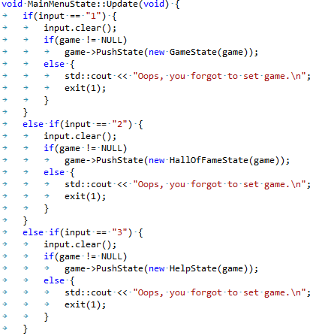
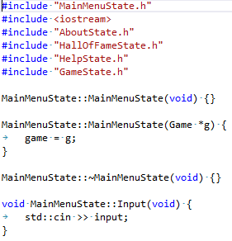
  - There is also the Game State, but that will be covered later on. Because we don't need it just yet, comment it out in the MainMenu code.
- Go to the .cpp file with your main() function and add the following:
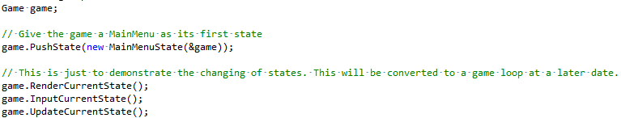
- Hit 'run' and you should end up with a semi-functional main menu. The only features missing are the 'quit' option and the Game State. For the purposes of this Spike, we will not be adding a Game Loop, so just add another lot of Input, Update and Render functions underneath (or use a for-loop) to see the effects.
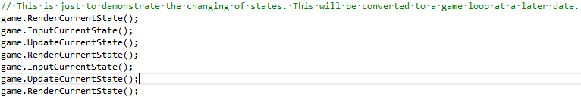
- Deallocate the memory
- x
- x
- x
- x
- x
- x
- x
- x
- x
- x
- x
- x
- x
- x
- x
- x
- x
- x
- x
- x
- x
- x

What we found out:

Recommendations:
- My original design (Appendix A) included a Main Menu Manager/Controller similar to that of the Game Controller demonstrated in the application. This would have allowed re-usable code to be shared across the Main Menu states, improving overall readability and maintenance. However due to the time constraint I decided to leave it until a later Spike, and only if it was a requirement for that task or would drastically improve turnaround time.
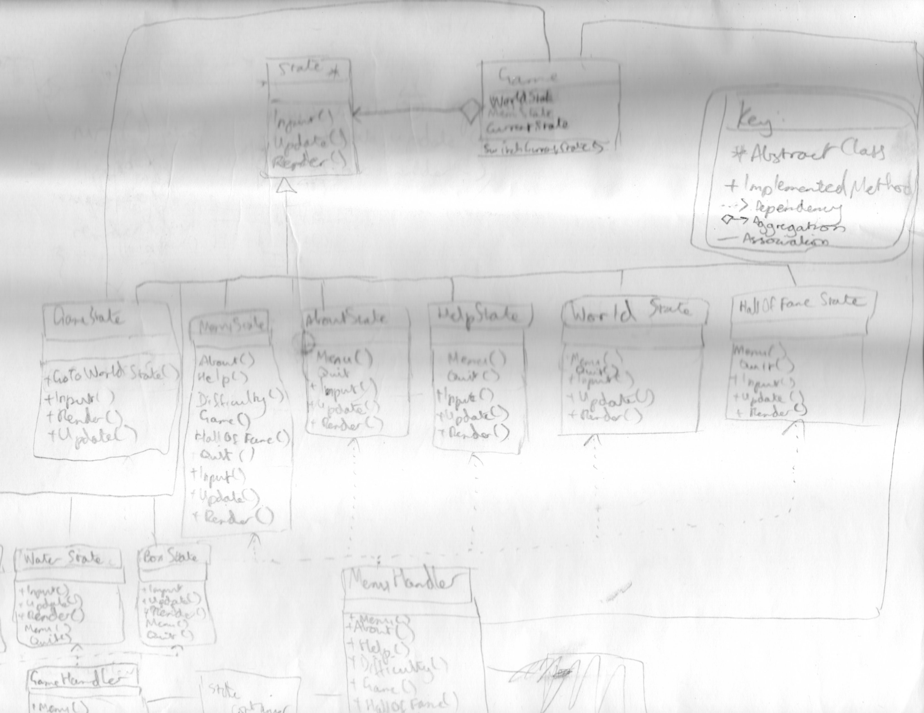
Appendix A:

Appendix B:
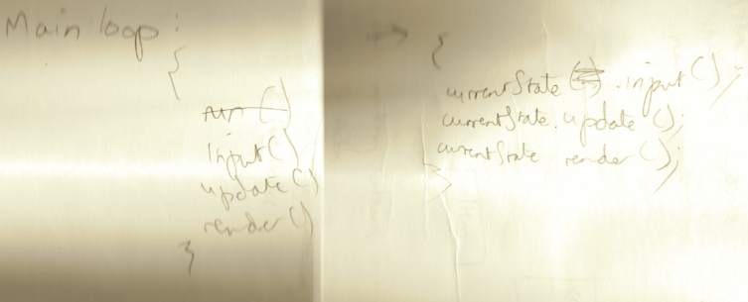
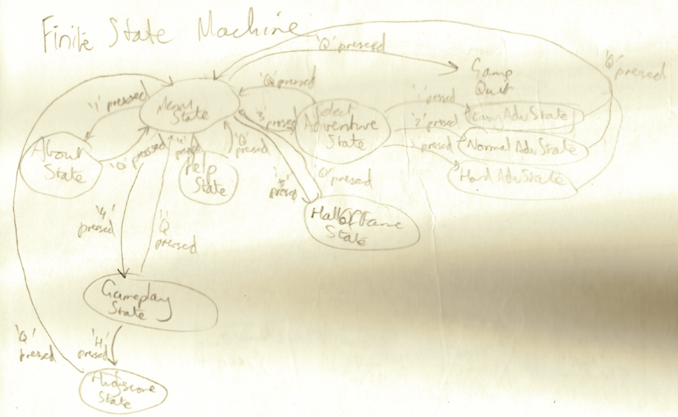
Appendix C:

Appendix D:

